Standard Item-attributes:

In standard BC you can set up different Attributes to extend the information set of different Items.

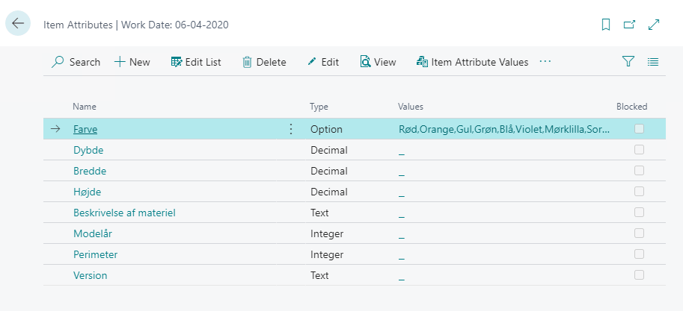

In addition to setting up the basic attributes, you can add Translations, which can then be used in other parts of the system, if you have a company working with different languages.

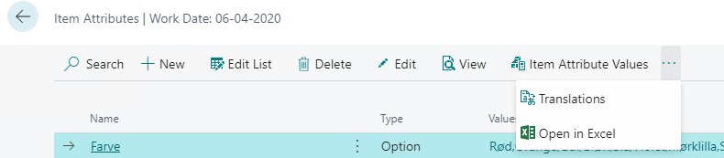

You use here the standard Windows language codes.
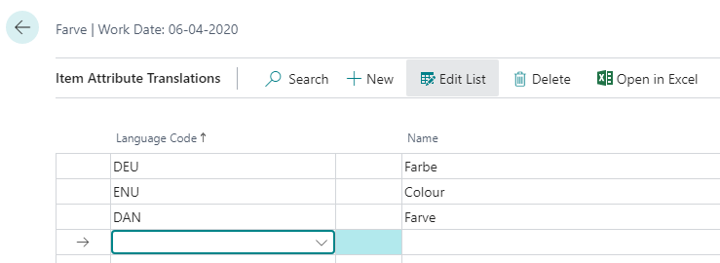

Then you can add values for different attributes to an individual item.

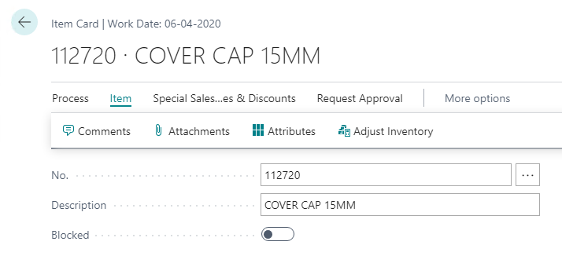

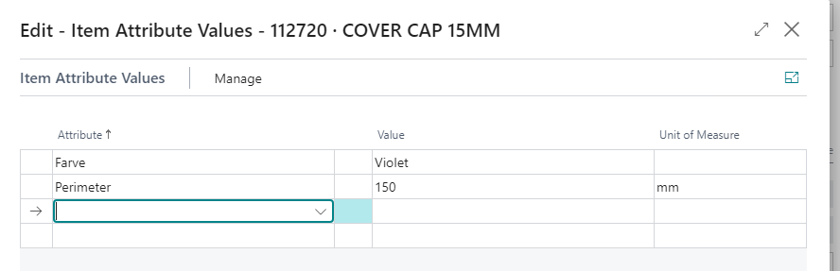

Attribute function in CadConnect:

It is possible to import attribute values through CadConnect and have theses values added to new created items. You might have more attributes created in BC than your CAD-system can supply. You therefore need to setup which attributes will be imported through CadConnect.

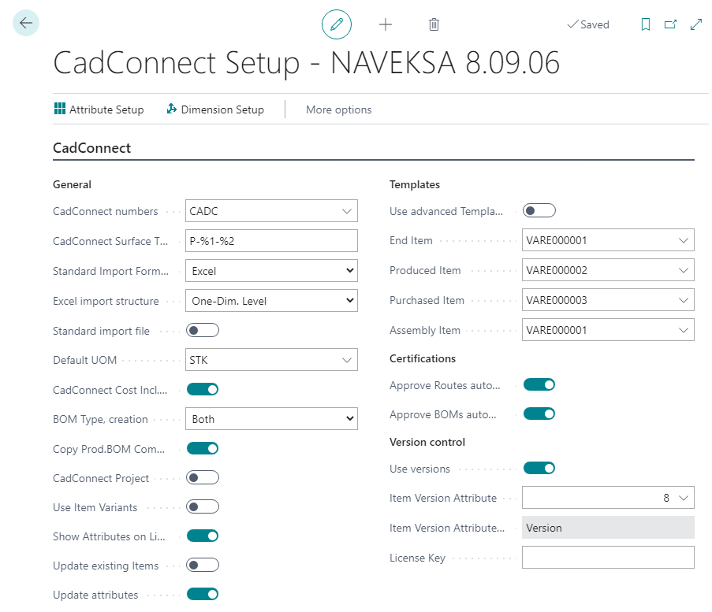

You need to assign CadConnect Attribute No.s with an value from 1 to 20.
You connect each CadConnect attribute to a BC Attribute. The system will use and show the System-internal no. and the attribute name.
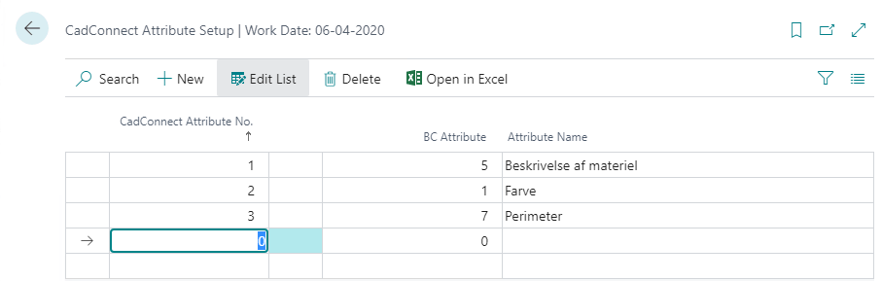

Then when you import an Excel-file in CadConnect, the data import will allow you to select the correct columns for the individual attributes.

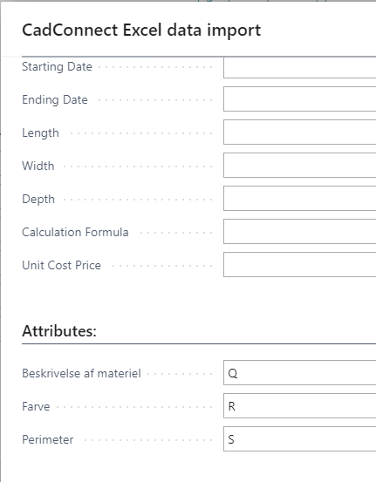

After the file-import, you can see the imported attribute values in the CadConnect-lines, if you have chosen that in the CadConnect Setup. You can always see the values in the Attribute Factbox at the right side of the screen.
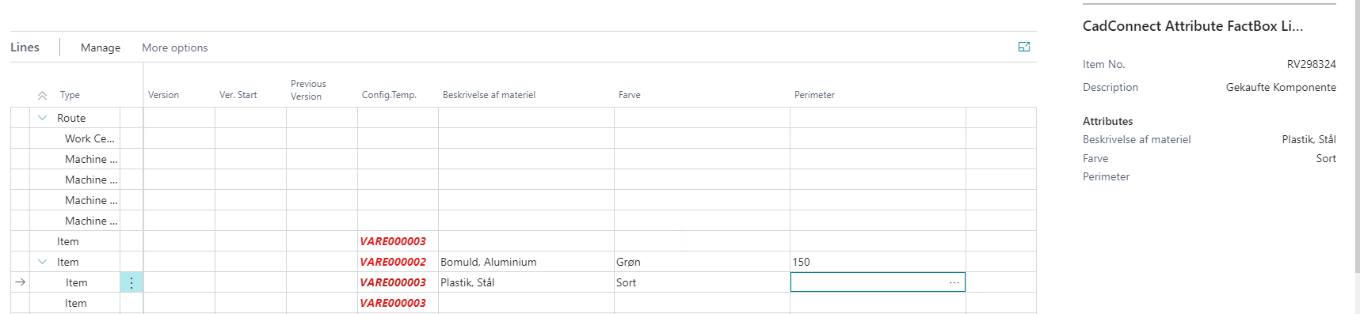
Attribute function in ShopFloor:

You can setup attributes for being displayed in the ShopFloor client.

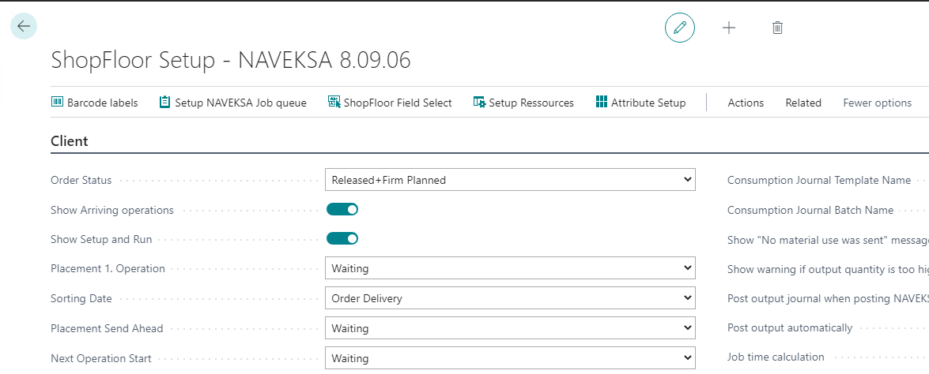

You need to assign ShopFloor Attribute No.s with an value from 1 to 10.
You connect each ShopFloor attribute to a BC Attribute. The system will use and show the System-internal no. and the attribute name.

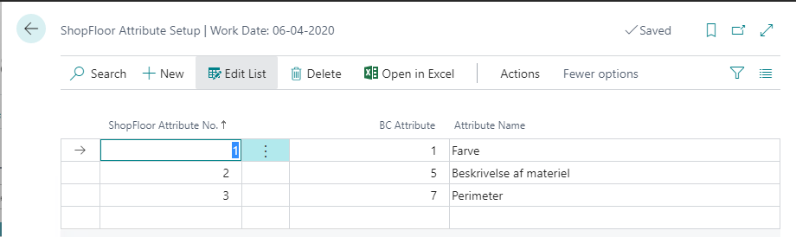

When you add SHopFloor attributes Setup, the values from the BC Item attributes are being synchronized to the ShopFloor Customer Fields, including translations. If you add translations or make any further changes in the BC attributes, you will need to synchronize these settings to the ShopFloor Customer Fields. This is being performed by the Synchronize-function on the ShopFloor Attribute setup page.
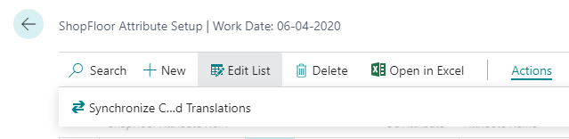

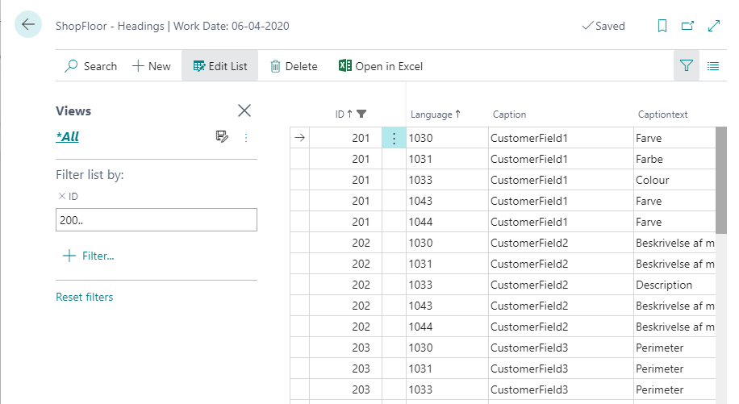

Selection of which Customer field / attributes you want to see in the ShopFloor client, is done from the ShopFloor Setup page and the Field Select function.
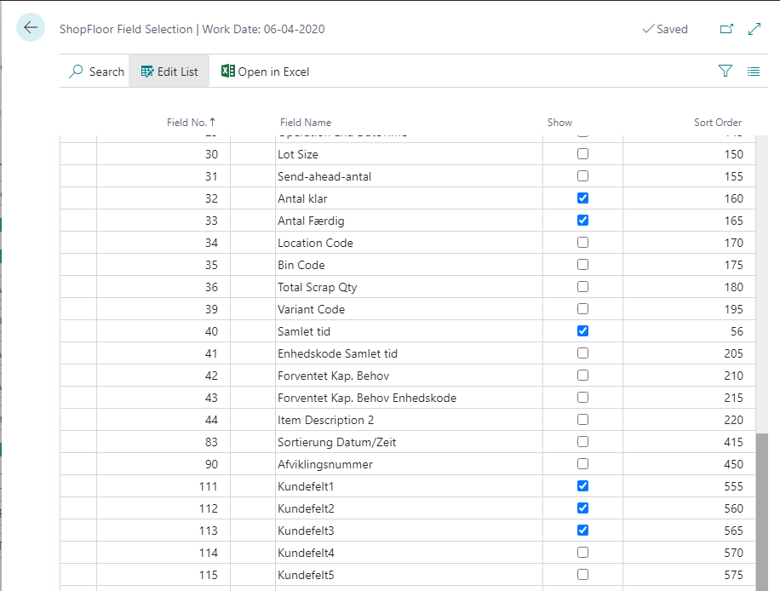

As standard the attribute values will be selected from the item card and shown on the operation lines for the item. As an additional setup possibility, you can add attribute values to the operation lines in the ShopFloor Planning page. This will then overrule the values from the item card.
