NAVEKSA A/S

ShopFloor solution
Short introduction to capabilities

The ShopFloor application consist of 2 parts

A production planner part running inside Business Central
An operator execution part running on a Microsoft .NET terminal app at the shop floor

The NAVEKSA solution is a solution that supports modern manufacturing execution, bundled execution, multi- job operator, operator running more jobs simultaneously, in-line process quality control, everything ultimately performed paperless
Our solution is comprehensive data collection, but we emphasize the value of shop floor management – sequencing, load control, queue control, resource assignment, prioritization.
So think about efficiency – we do.

ShopFloor solution
The Production Planner Part

The production planners
“playground”

- Select the planning level on production orders
The production planner selects the planning level (resource) he wants to work with.
Planning levels (resources) are dealt with in one of 3 different definitions.

- Resource totals (work center group)
- Resource group (work center)
- Resource level (production resource)

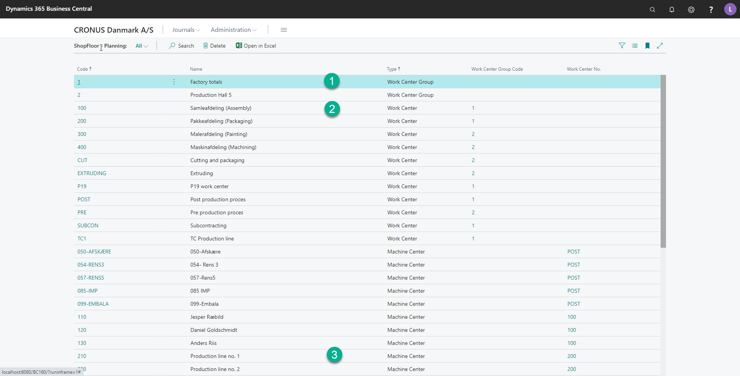

What is a planning level?
A planning level is the detailed resource level the planner wants to work on doing his work – overview, sequencing, prioritization, and queue control.
A work center group can be “Factory totals”, Production hall no 1, Production hall no 2 or another desired aggregate level.
A work center is the detailed resource level for a group of similar machines/people – CNC drilling, assembly, where all resources in the group can perform the same job. A work center belongs to a work center group.
A production resource/machine center is a specific machine / specific machine with its own capabilities. A production resource/machine center belongs to a work center.

Resource hierarchy schematic:

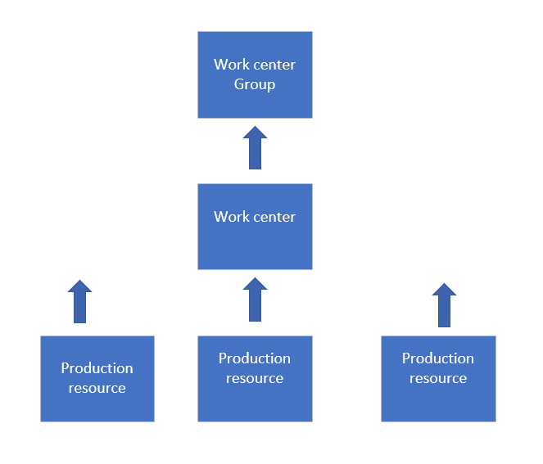

Have a look at the execution situation for the selected planning level (Resource)

- Running (Active) orders
- Queuing (Waiting) orders
- Arriving (Later) orders.

Running orders are the orders which are being worked at now, which means active, which means the process has been started. The waiting orders are queuing up at the facility, waiting to be worked at. The arriving orders are orders elsewhere in the system, arriving later at this facility to be worked on.

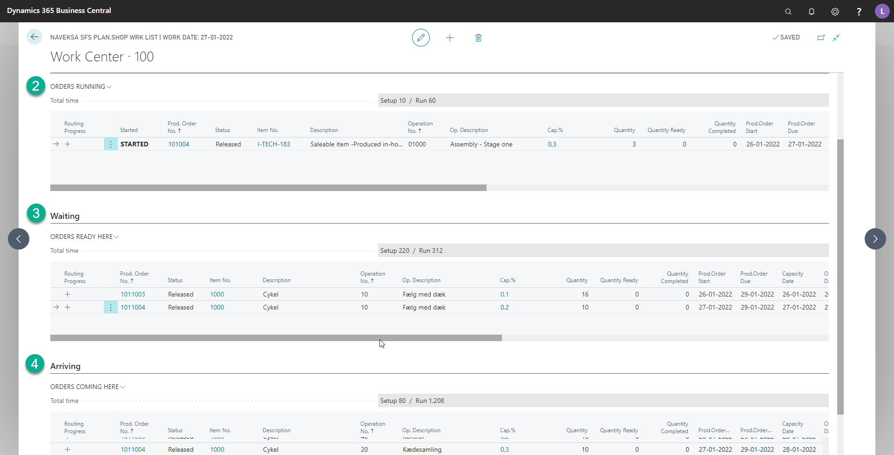
What is Running, waiting and arriving orders?
You can compare the different statuses with daily days situations where things are being served at a service facility.
Examples:
Shopping in the supermarket:
At the facility check-out counter some people are checking out right now, others are waiting in the queue at the counter to check out, others are still filling their basket.
Airport:
Some people are checking in in at the counter, handing over their luggage, and receives a boarding card. They are status Running (active), others are queuing up to be served at the check-in counter. They are status Waiting, and other are still on the road heading for the same flight. They are at status Arriving.
If we now exchange the service facility with the security check, the same process is repeated. Some people are being checked, others are waiting, and others are arriving, they are still checking in or on the road to the airport.

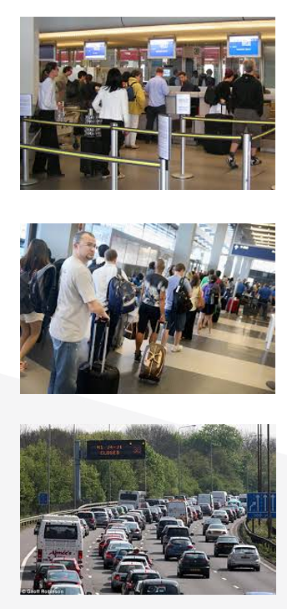
Have a look at the Running, Waiting and Arriving “real-life” queue principle:

- Planners’ playground
Performing production order maintenance / sequencing

The individual order can be viewed and maintained in many ways:

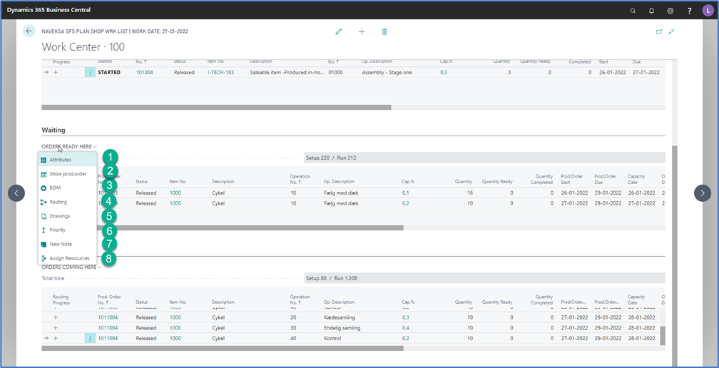

- Assign company attributes to order - Up to 10
  - You can operate with 7 item attributes and 3 order specific attributes
- Show production order in BC
  - A look up to the order in BC
- Show and maintain the order bill of material
  - Maintain the original Bill of material
- Show and maintain the order routing/ attach detailed process documents
  - Visual instructions can be attached
- Show drawings and order related papers
  - Drawings, documents etc. can be attached or retrieved automatically from various sources.
- Planner tool to change execution sequence
  - The planner has the capability to change the planned execution sequence by assigning priorities to an order. Priorities overrides the default execution sequence.

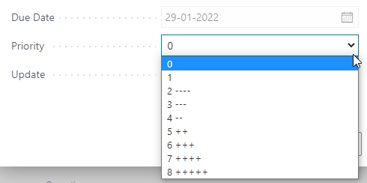

- Planner tool to add various notes to the order
  - Order, process notes can be added
- Assign or re-assign specific resources works this way: An order process is planned to be executed at work center 200. Now the planner wants to assign dedicated resources to perform this process. In the example below he selects the second process and assign 3 specific resources to do the job.
This is now handled the way that 3 parallel process steps are created – 1 for each resource assigned.

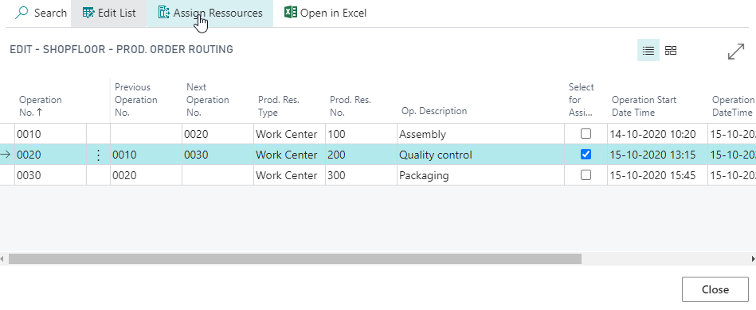

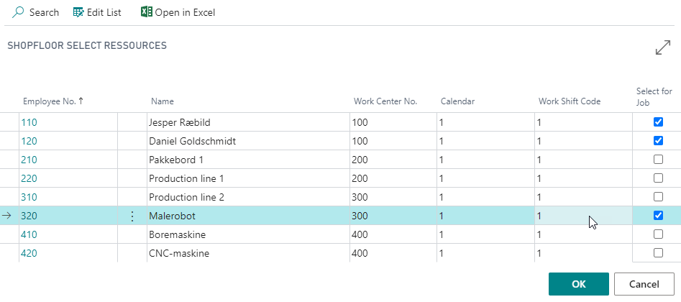

- Performing resource queue monitoring

- You can click on Cap% (Capacity load %) to see the actual queue load including a forecast for future built up or down at the chosen resource.
- Drill down capabilities with view by day, week, month etc. and see load by period or accumulated is available.
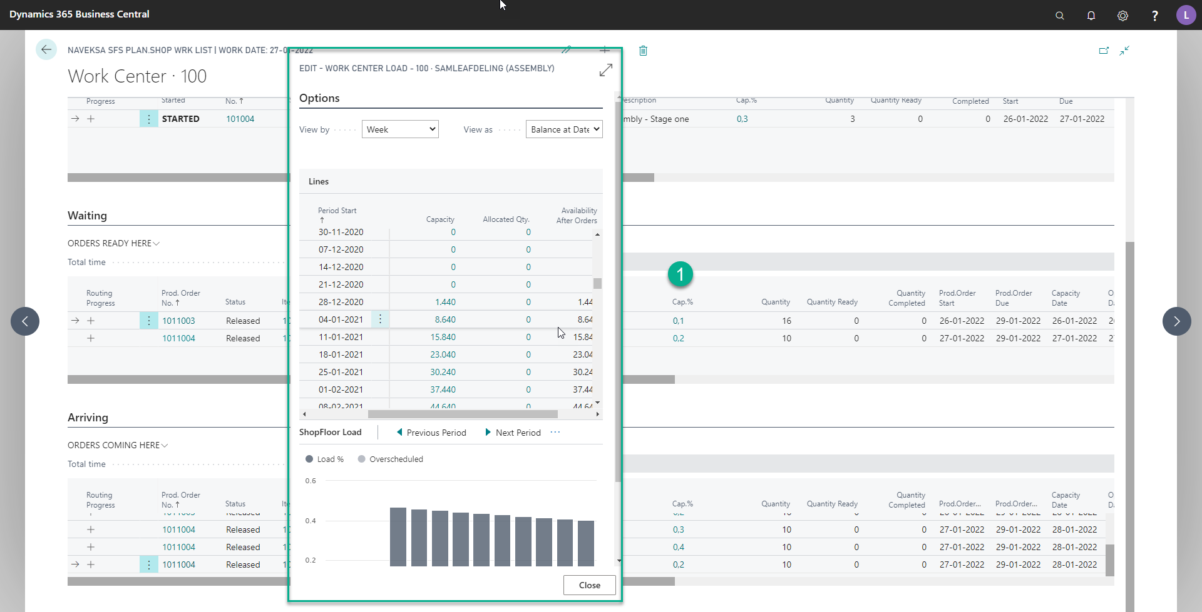

ShopFloor solution
The Operator Execution Part

The operator tool

Answers the important question:

“What shall I work on as the next”
with all information
in one handy place.

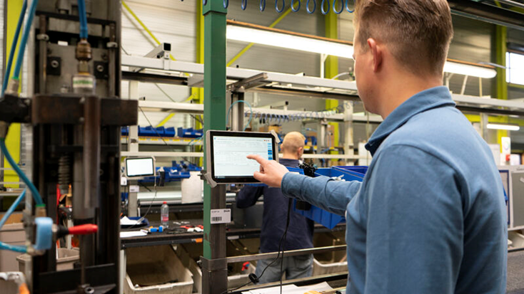

- Working with the operator terminal

  - The operator terminal is a solution which runs on a PC or a tablet. If the device is soft touch device, it can be operated just with the fingers. Also, the terminal can be operated just with the use and reading of various QR-codes.
  - The terminal reflects all the things the planner has done, so the operator just must follow what’s on the screen.
  - That is according to bullet 1 – Select the proper resource, according to bullet 2- Select the first line in Waiting, and bullet 3 - click on all the dark-blue buttons to see further information (Dark blue buttons means there are underlying information for the execution of the job.
    - Underlying information (Bullet 3) is:
      - Have a look at the order bill of material and see if there any component shortages.
      - Have a look at the order routing to get the overview og the process.
      - Have a look at various drawings/documents related to the order.
      - Have a look at the detailed process instructions and/or process drawings/documents.
      - Issue materials
      - Have a look at general order instructions and communicate with planner.
Bullets 6-10 are:
Starting a job
Ending a job – setup, part quantity, pause, completion, stop
Report QC figures as an in-line process with outputting a job.
Various print options – pallet labels etc.
Time & Attendance clock in/out if included.

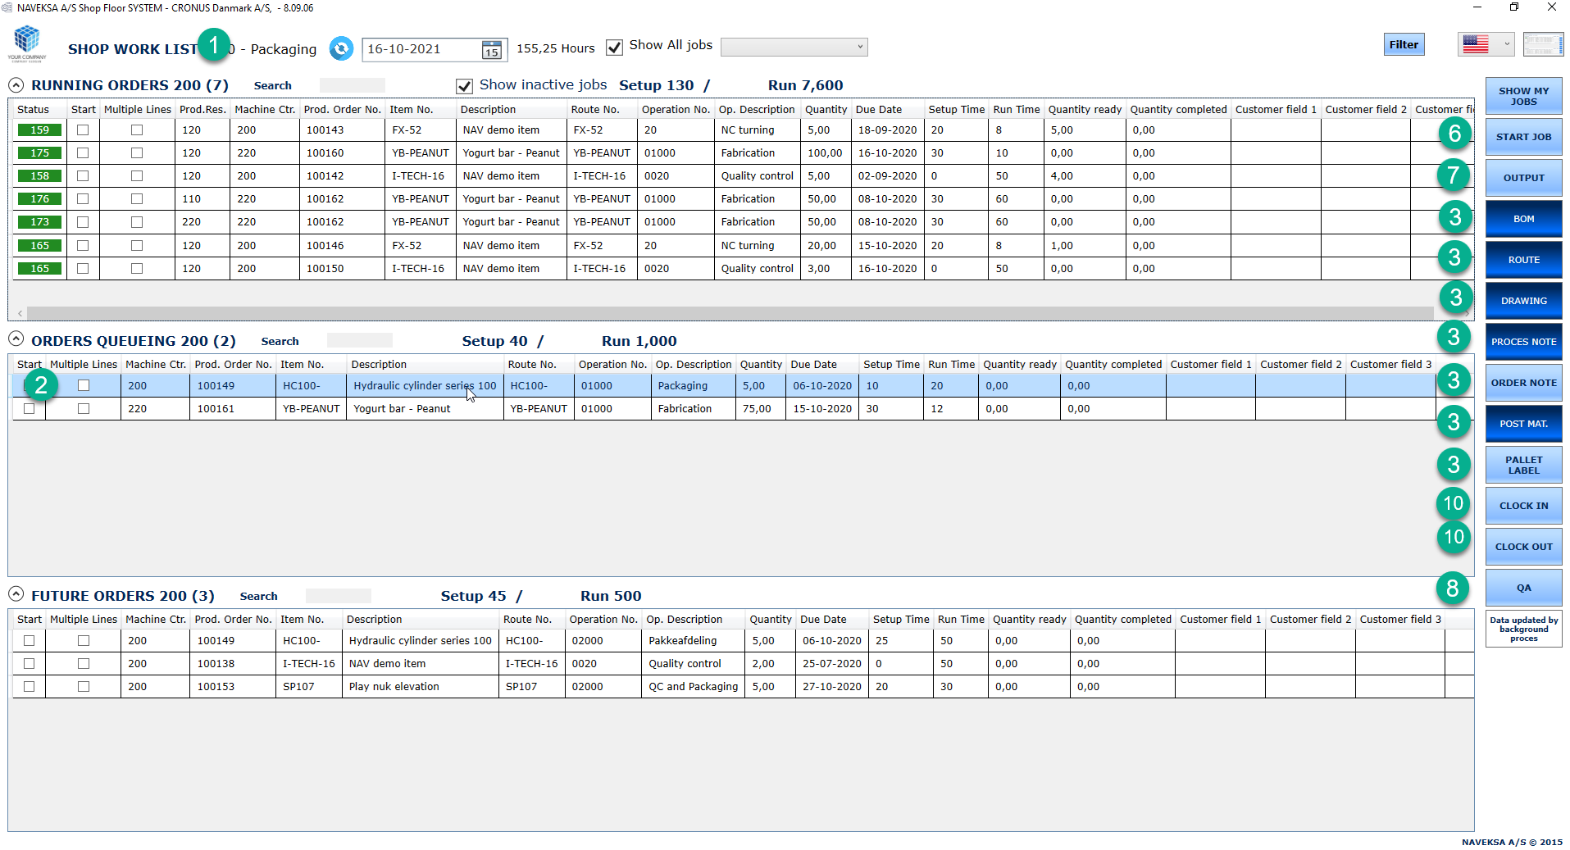

- Starting a job
  - Starting a job is done clicking the “Start job” button with an order line selected and tell the system who is going to run this job – employee, machine, or resource.

Please note the multiple operators can run on the same job, and that an employee can run on several orders simultaneously.

Please note that starting a job can be across multiple orders (Bundling), and please note that starting a job also can be attaching a new job to an existing running job.

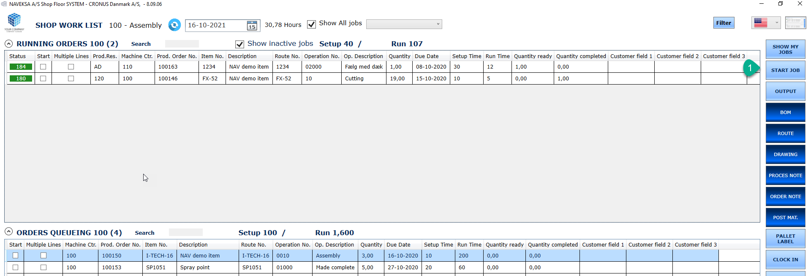
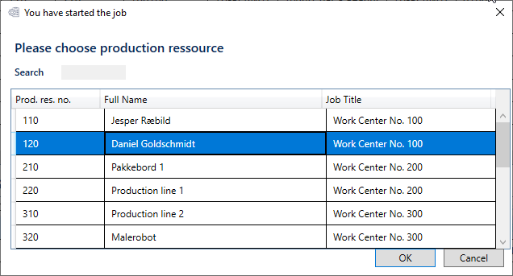

- Ending a job (output reporting)
  - Output from a job is done clicking the “End job” button and tell the system which operation has been performed.
  - A job can be a single job or a multi-order job, performed by one or more resources.
  - A proper action must be chosen – is it setup, part quantity, a pause, a completion (end job) I want to perform.
  - More options exist to modify/complete the end job transactions – actual production resource, manual start-/ending time/traceability/location-bin, scrap etc.

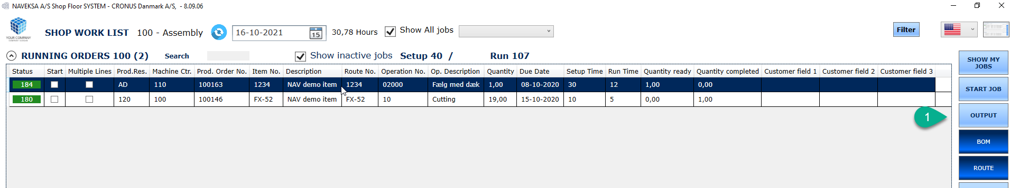

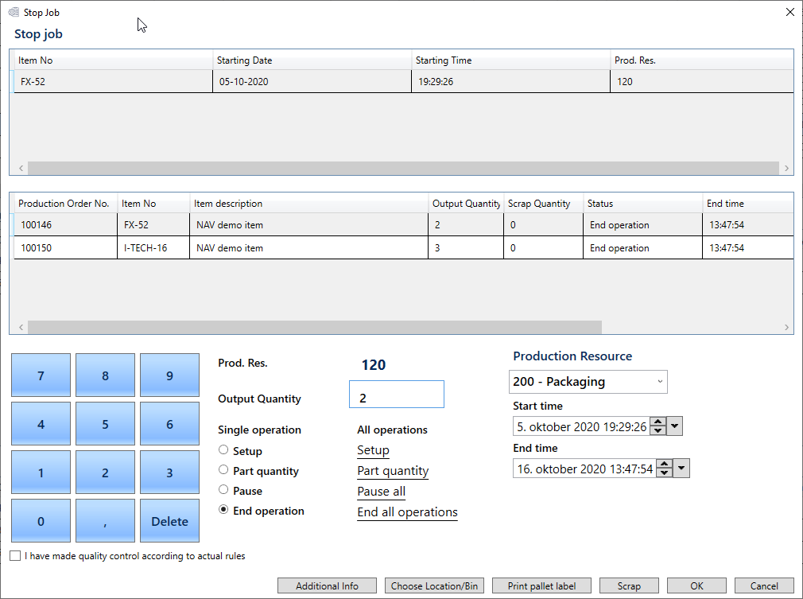

ShopFloor solution
Setup capabilities

The shopfloor solution offers a comprehensive setup

This to be able to tailor the solution to the user needs
and to avoid the need for additional
programming changes
to the solution.

- Solution tailoring

The Solution facilities to tailor the solution to specific needs – rules and features to be used or applied.

- 60 questions to be answered for wanted use.
  - Sections for client, quality, materials, planning, print and general.
- Defining job q setup (technical house-keeping)
- Definitions on using bar/QR codes.
- Defining screen content and wording.
  - Field/column content/user fields.
- Defining resource setup.
  - Manual start-/end time, production resource.
- Defining use of item/production order attributes (Customer fields)
  - 7 BC item attributes available/ 3 order specific attributes.

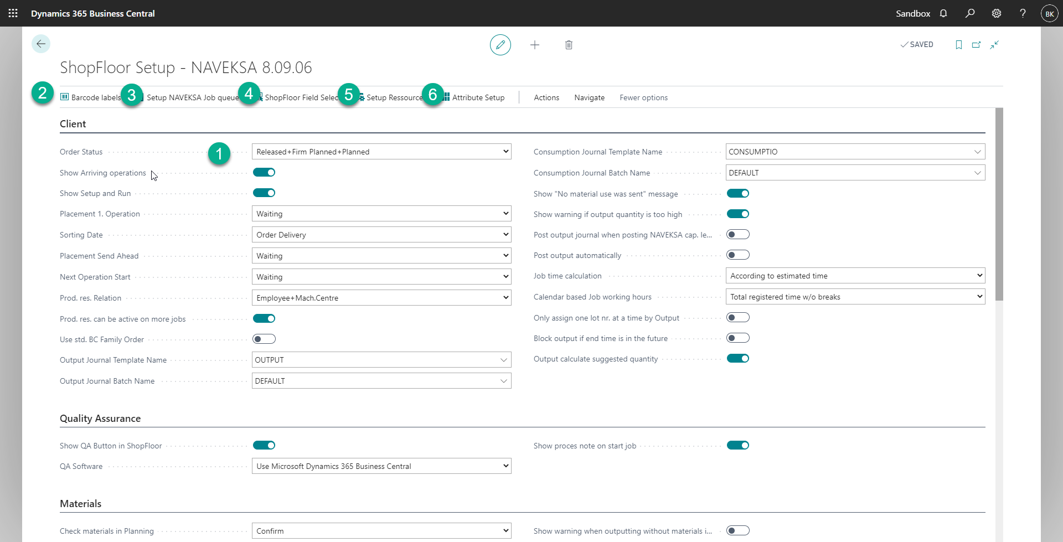

ShopFloor solution
KPI reporting

The shopfloor solution offers comprehensive historical
data
for KPI measurements

- KPI reporting
As standard the ShopFlor solution offers access to extensive data about job execution – who, how long time, quality data, execution comments, reason codes etc.

The solution does not provide any standard presentation tools for showing these data.
But you have the possibility to generate your own reports and KPI measurements based on these data. This could be as simple as a query report or using more advanced Microsoft Power BI-tools.
Here is an example for monitoring Capacity – Hours of operation.

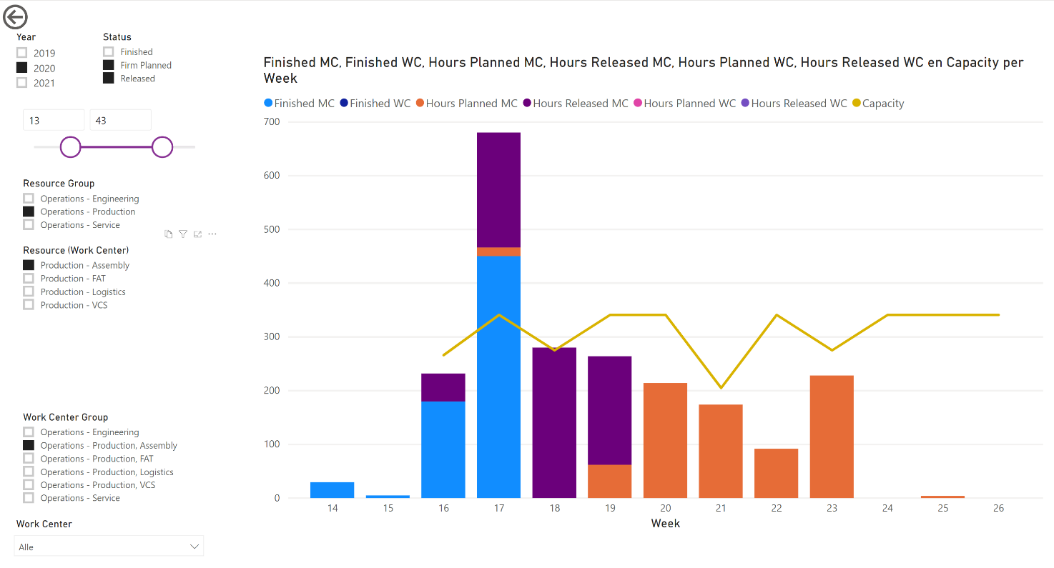

------ ***** ------
Watch our ShopFloor movies also:

ShopFloor – function view – 4 min - UK-version at https://vimeo.com/640268131
ShopFloor – Function view – 4 min - US version at https://vimeo.com/640268170
ShopFloor – Function view – 4 min - DE version at https://vimeo.com/640268096
ShopFloor – Function view – 4 min - DK version at https://vimeo.com/640268056

------ ***** ------

